UHF MICOR Mobile Alignment Procedure

This procedure is to be used after completion of the conversion procedures adapting the UHF MICOR Mobile for repeater operation and assumes the modification was accomplished per that procedure. The following equipment is required to perform the alignment procedures:

Motorola Portable Test Set (S-1056B) with TEK-37 Cable, Motorola TEK-5 Meter Panel with TEK40 MICOR Adapter, or equivalent.
DC Power Supply capable of producing 13.6 VDC at the Rated Current Requirement | 50 Ohm Dummy Load Rated  at Transmitter Power Output
RF Signal Generator | Frequency Counter
Deviation Meter | RF Wattmeter
IsoTee | DC Voltmeter
Audio Oscillator | Oscilloscope Probe
Various RF Adapters and Cables | RCA Phono Jack and Plug adapters
Alignment Tool Set | Clip Lead

Adjustment Locations Referenced in this Procedure are Illustrated in Figure 1.

STEP | ADJUSTMENT | METER POSITION / TEST POINT | STAGE AND PROCEDURE
Receiver Alignment Procedure
Connect all equipment as shown in Figure 2.
1 | L101, L102, L103, L104, L105 | - | Multiplier Coils:  - Adjust the cores of L101 – L105 to the end of the coil form farthest away from the circuit board.
2 | L106, L107, L108 | - | Injection Filter:  - Adjust the tuning screws for L106 – L108 until the top of each tuning screw extends approximately 1/8” below the receiver shield.
3 | L101, L102 | 1 | Channel Element Output:  - Alternately tune L101 and L102 CCW two turns at a time to obtain a peak on Meter 1.
4 | L103, L104 | 2 | First Doubler:  - Tune L103 CCW for a peak on Meter 2.  - Tune L104 CCW for a dip on Meter 2.
5 | L105, L104 | 3 | Second Doubler:  - Tune L105 CCW for a peak on Meter 3.  - Tune L104 for a peak on Meter 3.  - Re-peak coils until no further improvement can be made.
6 | L101, L103 | 3 | - Detune L101 until Meter 3 drops to 10 uA.  - Tune L103 for a peak on Meter 3.  - Detune L101 as necessary to keep reading below 10 uA.
7 | L101, L012 | 1 | - Alternately tune L101 and L102 for a peak on Meter 1.  - Repeat until no further improvement can be made.
8 | L106, L107, L108 | 3 | Injection Filter:  - Tune L106 for a dip on Meter 3.  - Tune L107 for a peak on Meter 3.  - Tune L108 for a dip on Meter 3.  Do not repeat.
9 | L109 | 4, 5 | Discriminator:  - Inject an 11.7 MHz unmodulated signal into the L110 hole on the receiver shield using an oscilloscope probe. Avoid contacting the circuit board.  - Adjust injection level to obtain Meter 5 saturation.  - Tune L109 for an exact zero reading on Meter 4. Verify the reading is exactly zero by switching the Meter REV switch between position A and B and observing meter deflection.  This adjustment is critical.
10 | L110, L111, L102, L113, L114, L115, L116 | 4, 5 | Preselector and Mixer:  - Unsquelch receiver by turning SQUELCH control fully CCW.  - Connect RF Signal Generator to receiver antenna connector  - Set output of the RF Signal Generator to 0 dBm.  - If the Audio and Squelch Board has not been modified to disable ‘AND Squelch’, disable the PL Decoder by setting the PL Monitor switch to ‘Off’.  NOTE:  If the receiver frequency has been changed more than 1 MHz, preset L111 – L116 so the top of the tuning screws are approximately 1/8” from the receiver shield.  - If the radio is equipped with the optional preamplifier, disconnect and bypass the preamplifier.  - Set the RF Signal Generator to the receiver frequency by observing Meters 4 and 5.  NOTE:  If no indication is seen on Meters 4 and 5, pull the antenna cable partially out of the jack so shield no longer contacts radio chassis. Set the RF Signal Generator frequency to the channel element frequency by observing Meters 4 and 5. Adjust L111 – L116 CW one turn at a time while watching Meter 5 for an increase above the noise level.  - Tune L111 – L116 for a peak on Meter 5, reducing RF Signal Generator output to keep Meter 5 out of saturation.  - Tune L110 for a peak on Meter 5.  - Repeat the adjustment of L111 – L116.  - Turn L111 – L116 CW or CCW as necessary until slugs are level.  - Repeat the adjustment of L111 – L116.
11 | L106, L017, L018 | 11 (Receiver Audio) | - Tune L106 – L108 for best noise quieting (minimum meter indication). Maximum Meter 11 sensitivity is obtained by placing multiplier switch on test set to the .2 VAC position.
12 | L111, L112, L113, L114, L115, L116 | 11 (Receiver Audio) | - Tune L111 – L116 for best noise quieting.  - Repeat until no further improvement can be obtained.
13 | C1, C2, L111 | 5, 11 | Preamplifier:  - If radio is equipped with optional preamplifier, reconnect the preamplifier.  - Tune C1 and C2 for maximum Meter 5 reading.  - Tune C1, C2, and L111 for best noise quieting on Meter 11.
14 |  | 4, 11 | Perform 20 dB quieting test:  - Set the MULT switch on the test set to 2 VAC.  - Set test set SPKR switch to LOAD and disconnect speaker.  - Set the SQUELCH control fully CCW.  - Adjust VOLUME control for 2 VAC on test set meter.  - Connect RF Signal Generator to radio antenna connector.  - Adjust RF Signal Generator output to 0 dBm.  - Set RF Signal Generator to produce unmodulated signal.  - Adjust RF Signal Generator frequency for a reading of exactly zero on Meter 4.  - Decrease RF Signal Generator output until Meter 11 reads 0.2 VAC.  - Note RF Signal Generator output level. This level should be 0.5 uV or less for a non-preamplifier equipped radio for 0.25 uV or less for a preamplifier equipped radio.
15 | STD FREQ Warp Coil | TP302 | Adjust Offset Oscillator:  - Connect a frequency counter capable of measuring 16.7 MHz between TP302 and ground.  - Unplug exciter input cable J300 from receiver RF deck, located on the Control Board side of RF deck.  - Remove the PL reed from the PL Encoder or otherwise disable the PL Encoder.  - Key the transmitter and adjust the Standard Frequency Warp Coil for exactly 16.7 MHz.  This adjustment is critical.
Standard Exciter Alignment Procedure
Connect all equipment as shown in Figure 3.
16 | - | - | - If using the S1056B test set, adjust the Function Switch to Transmitter and the Sensitivity Switch to 100 mV.  - If using TEK-5 Meter Panel, set the Selector Switch to Position B.
17 | Power Set | - | Power Output:  - Turn the Power Set control fully CCW (minimum power).
18 | L301 – L307 | - | Pre-alignment:  - Adjust the tuning screws in the exciter output filter, L402  - L407, fully CCW until each screw is fully extended.  - Adjust L401 so it is flush with the circuit board.
19 | TP301 | 4 (Ref A) | - Ensure test meter is connected to exciter metering plug.  - Short TP301 to ground to disable the offset oscillator. Meter 4 will read zero with TP301 shorted and the transmitter keyed.
20 | L401 | 2 (Ref A) | Offset Mixer Output:  - Remove the exciter input cable from the receiver RF deck and connect it to the RF Signal Generator using an adaptor.  - Set the RF Signal Generator to the transmitter frequency and the output level to -10 dBm.  - Key transmitter and adjust L301 CW for a peak on Meter 2.  - Adjust RF Signal Generator for a near center-scale reading.
21 | L302 – L307 | 2 (Ref A) | Exciter Filter:  - Key transmitter and adjust L302 for a dip.  - Adjust L303 for a peak.  - Adjust L304 for a dip.  - Adjust L305 for a peak.  - Adjust L306 for a dip.  - Adjust L307 for a peak.  - Unkey the transmitter  - Adjust L302 – L307 CW ½ turn each.
22 | TP301 | 4 (Ref A) | Offset Oscillator:  - Remove the exciter input cable from the signal generator and reconnect to the receiver RF deck.  - Remove the short from TP301.  - Key the transmitter and observe a Meter 4 reading of 30 – 40 uA (15 – 20 uA on TEK-5).  - Unkey the transmitter.
23 | L302 – L306 | 2 (Ref A) | Exciter Filter:  - Key the transmitter.  - Adjust L302 CCW to the first Meter 2 dip.  - Adjust L303 CCW to the first Meter 2 peak.  - Adjust L304 CCW to the first Meter 2 dip.  - Adjust L305 CCW to the first Meter 2 peak.  - Adjust L306 CCW to the first Meter 2 dip.  - Unkey the transmitter.
24 | L302, L307 | 5 (Ref B) | Exciter Filter:  - Key transmitter and adjust L307, then L302 for peak on Meter 5.
25 | L301 | 5 (Ref B) | Offset Mixer Output:  - Adjust L301 for Meter 5 peak. The tuning tool detunes L301, therefore it is necessary to remove the tool and check for meter peak. Repeat until peak is obtained.  - Unkey the transmitter.
PA Power Setting Procedure
26 | Power Set, Drive Limit |  | - Remove the Power Control Board shield.  - Connect the test meter to Power Control Board metering socket.  - Connect a wattmeter to transmitter antenna connector.  - Adjust Drive Limit control fully CW (maximum drive limit)  - Adjust the Power Set control ¼ turn up from fully CCW.
27 | Power Set | Wattmeter | Power Set:  - Key the transmitter and adjust the Power Set control CW until power output under Drive Limit in Table 1 is obtained.  - If power limits before that value is obtained:  -- Adjust Power Set control fully CW.
28 | Drive Limit | Wattmeter | Power Limit:  NOTE:  For proper operation of the power leveling circuitry, the Drive Limit control must not be set for any lower power output than that given in Table 1. In radios where rive limit power output level is not obtainable, the Drive Limit control can be set to minimum.  - Key the transmitter  - If proper level was not obtained in the step above:  -- Adjust Drive Limit control CCW to value indicated in  Table 1 under ‘Drive Limit’.  - If Drive Limit control has no effect”  -- Set Drive Limit control fully CW (maximum drive limit).  - If Drive Limit control cannot obtain a high enough reading:  -- Set Drive Limit control fully CCW (minimum drive limit).  - Unkey the transmitter.  - Replace Power Control Board Shield and reconnect the test set to the metering socket.
29 | Power Set | Wattmeter | Power Set:  - Key the transmitter  - Adjust Power Set control CCW  - Set power output per Table 1 under ‘Power Set’.  - Unkey the Transmitter.
30 | - | 5 (Ref B) | PA Current:  - Key transmitter and check current indication. For radios in the 406 – 470 MHz range, the following maximum current levels are acceptable:  T34: 24 uA T44: 37 uA T54: 29 uA T74: 43 uA
Determine Final Stage DC Power Input
31 | DC Current to Final PA | 5 (Ref B) | Final PA Stage Collector Current (Ic):  - Observe Meter 5 reading.  - Multiply Meter 5 reading by the factors listed below to determine actual Ic.  T34 and T44 radios: 0.25 T54 and T74 radios: 0.5
32 | DC Voltage to Final PA Stage | DC Voltmeter | Final PA Collector Voltage (Vc):  - Measure the PA Collector voltage between the two large feed-thru capacitors located at the center front of the radio on the transmitter side.
33 | Final Stage DC Power Input | - | Final Stage DC Power Input:  - Calculate the final input power: Pin = Vc * Ic.
Transmitter Carrier Frequency Setting Procedure
34 | Channel Element Trimmer Capacitor | Frequency Counter | - Insert IsoTee between transmitter output and dummy load.  - Set the IsoTee for maximum isolation.  - Connect the output of the IsoTee sampling port to the frequency counter.  - Remove PL Encoder reed or otherwise disable PL Encoder.  - Key the transmitter and adjust the Channel Element trimmer capacitor for the correct transmitter frequency, as displayed on the frequency counter.  - Unkey the transmitter.
Transmitter IDC Adjustment Procedure
35 | - | - | - Set the S-1056B test set Function Switch to Transmitter.  - Connect an Audio Oscillator to the test set and set the oscillator for 1000 Hz at 1 VRMS (1.41 V P-P) output.  - Ensure the PL Encoder is still disabled.  - Key transmitter and adjust STD IDC for +/- 5 KHz deviation  - Reduce audio oscillator output to 0.25 V- RMS. Verify that deviation is still at or near 5 KHz.  - Reinstall the PL Encoder reed or otherwise re-enable the PL Encoder.

Table 1
Power Output Specifications: 450 – 470 MHz
Model | Power Output | Drive Limit | Power Set | DC Input
T34 | 25 | 31 | 25 | 80
T44 | 45 | 55 | 45 | 120
T54 | 75 | 88 | 75 | 180
T74 | 100 | 125 | 100 | 270

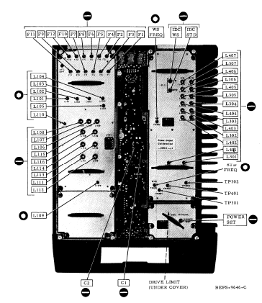

Figure 1
Adjustment Locations

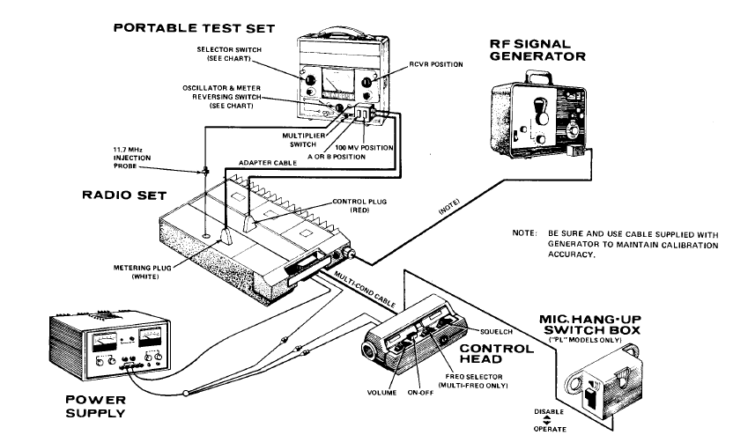
Figure 2
Receiver Alignment Test Setup

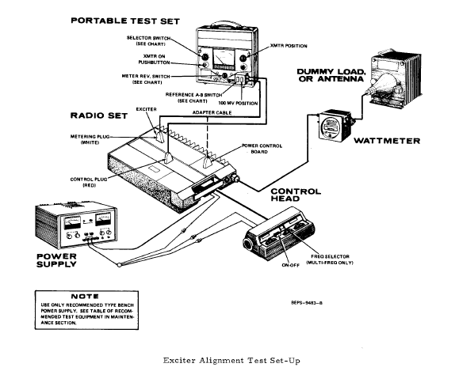
Figure 3
Exciter Alignment Test Setup

